Advanced React Patterns

# Reusable Code - basic

There are 2 things that we can reuse in React:

* UI
  + Component and Props
  + Children Prop
* Stateful Logic (logic with hooks)
  + Custom Hooks

# Render Props Pattern – advanced reuse of code

* Complete control by passing a **function** as a **PROP**
* The **Function** tells the component what and how to render

## How to:

1. Use the **render** prop to pass the function we want to use in the **List** component
   1. We pass the function for the **map** logic

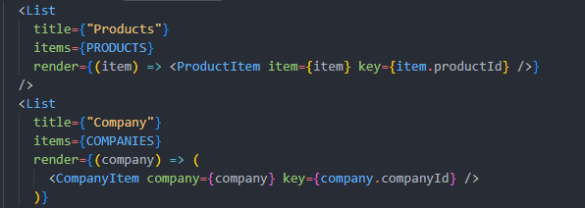

# Compound Component Pattern – advanced reuse of code

* For very self-contained components that need to manage their own state
* Fancy super-components
* We create a **Parent** component and then some **Child** components that will make sense only in use with the **Parent** component
* This will allow us to create **highly usable components** with an expressive API

## How

1. The **Parent component** will keep the **STATE**
2. We will use the **CONTEXT API** to pass **STATE** to children Components